Brain Modelling
Lezione 2 - 6/10

Neurons
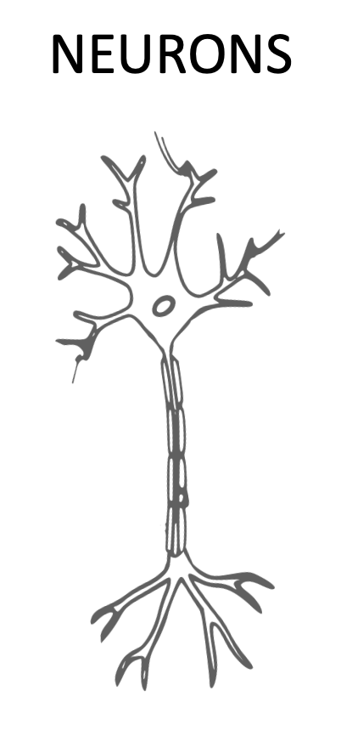
There is a variety and variability of morphology in neurons. Neurons can have different shape and size. The size can be very different [the bars in the image represent 100 micrometers].
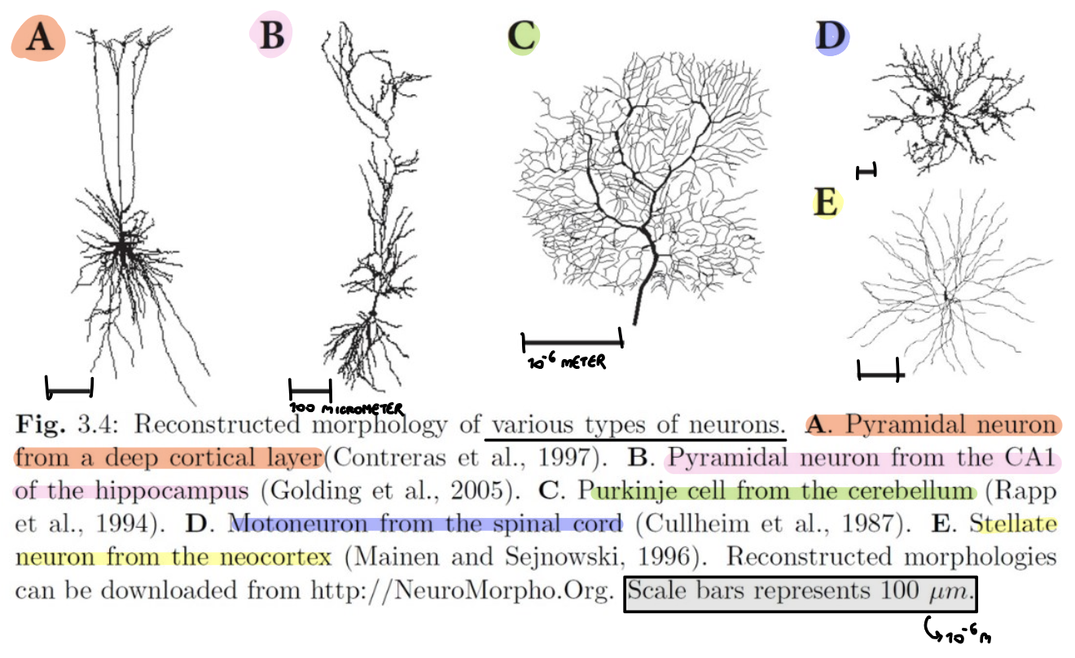

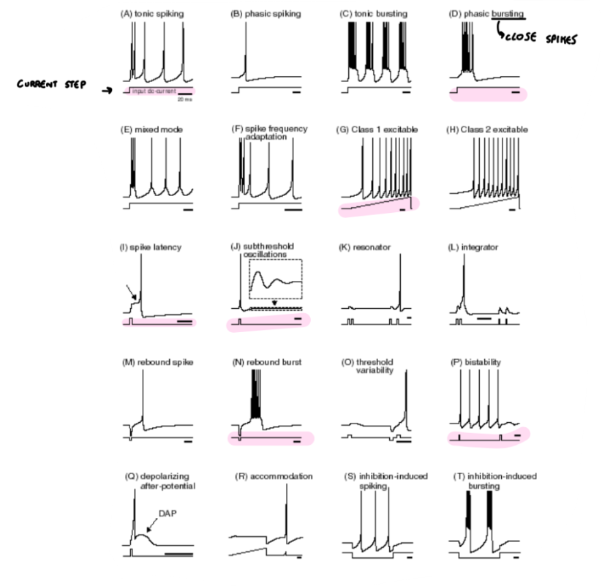
Biological neuron firing patterns
Neurons can generate different patterns that depend on tahe input. Can have different firing patterns, also can have different phenomena such as adaptation (when a neuron starts to decrease the firing frequency after a while of the same input, because at first it is something new).

Bursting = group of spikes

There can also be different electro-responsiveness generated by neurons that depends on the input and on the neuron itself.

Neuronal biophysical mechanisms
There is a huge number and variety of ions and molecules, many carry charges that can be either positive or negative, and they are inside the membrane of neurons. The main ions that are usually considered are potassium, sodium, calcium, chloride. They can have different concentration inside and outside.
Most of the time, there is an excess concentration of negative charge inside a neuron.
The resting state is negative because there are more negative charges inside.
Positive ones are attracted outside close to the membrane and there is a capacitor that creates different voltage.
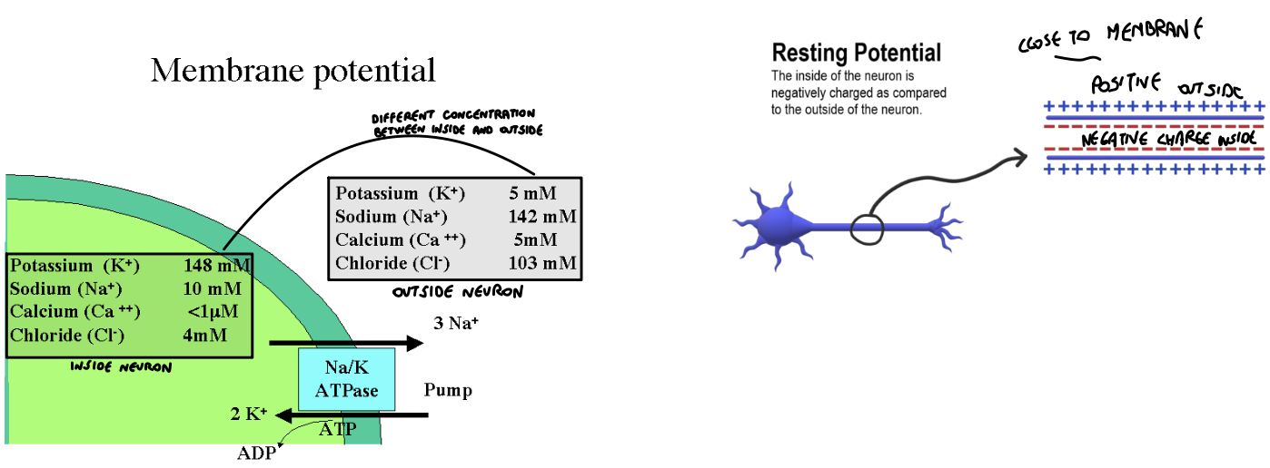

Neuron membrane
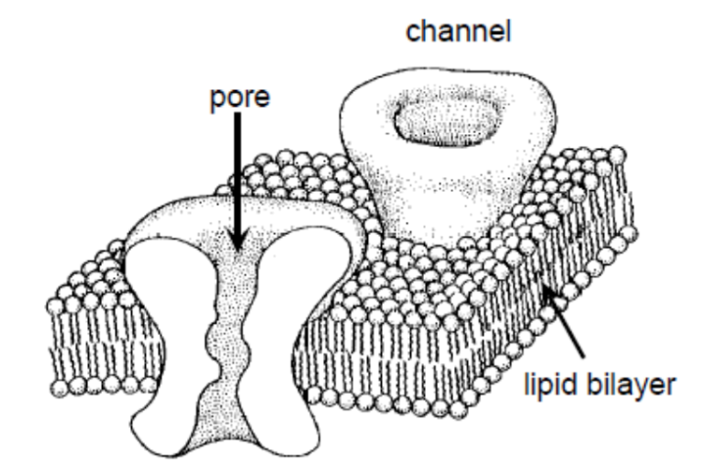
The neuron membrane is made of lipid bilayer of 3/4 nm thick. The cell membrane acts as a capacitor (it is an insulating feature). The cell membrane forms the border of a neuron and it also separates two good conductors (the fluids outside and inside the cell).

Inside the cell membrane there are the ions channels that are 10 nm long. These channels allow the ions to pass from the outside to the inside, and vice-versa. The ions channels can be open or close to allow or not the flow of ions.

There exists dozens of different types of channels and on the total surface of a neuron there are 2 millions of channels (the density is computed on the micrometer square).

There are many channels that allow the flow of a specific element (like sodium channels) and are highly selective, permeability means that more than one type of ions are allowed.

Membrane potential
By convention, the potential of the extracellular fluid outside a neuron is defined to be 0. Also when a neuron is inactive the excess internal negative charge causes the potential inside the cell membrane to be negative.

If there is a small positive stimulus the neuron starts to depolarise a little bit. Not strong enough to generate action potential (is a spike).
Opening or closing of ion channels → potential can change (range about -90 to +50mV)

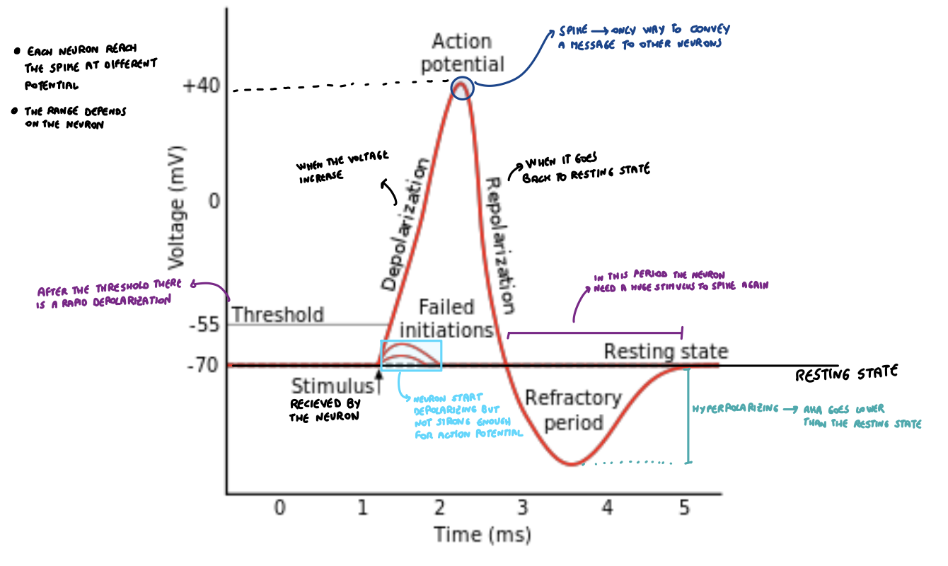

Thermal energy

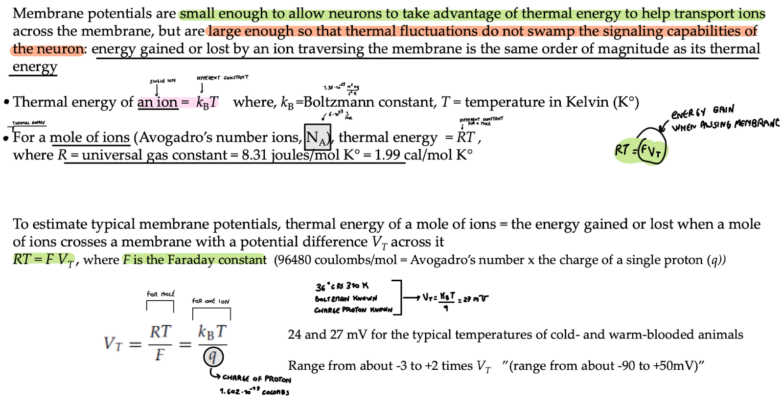

In practical terms, the thermal energy of an ion tells you how much kinetic energy the ion has due to its random motion at a specific temperature. It's an important concept in understanding the behavior of particles in a system when they are subject to changes in temperature.

Thermal energy of an ion: $E = K_{b}T$ where:
- K_{b}: Boltzmann constant: $k_{b} = 1.38×10^{-23}\frac{m^{2}Kg}{s^{2}K}$
- T: temperature in Kelvin (0 K = -273.15 C)

Thermal energy for a mole of ions: $E =n RT$ where:
- n: number of moles of ions, that is N_{A} (Avogadro’s number) 6*10²³ 1/mol
- R: universal gas constant R = 8.31 joules/Mol
- T: temperature in Kelvin (0 K = -273.15 C)

Typical membrane potential:
